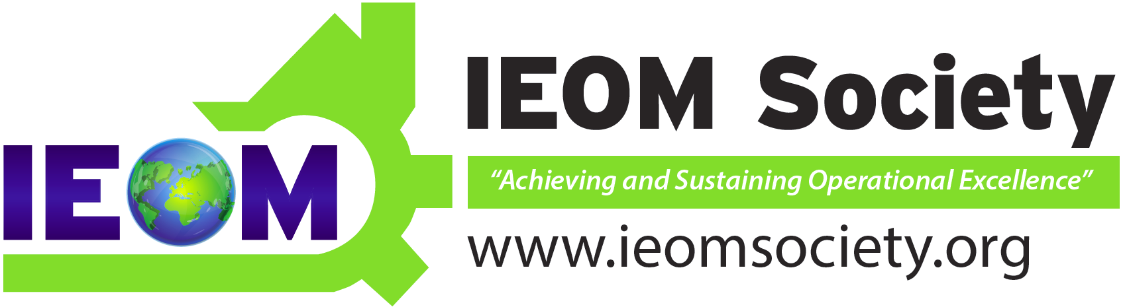
Join the NEW
Industrial Engineering and Operations Management (IEOM)
Student Chapter
We’re all about
Networking
Professional Development
Plant Tours
International Poster Competitions
Workshops, Conferences & Seminars
Listening & Learning
Job Opportunities / Career Planning

Contact:
Diversity is the key to our success.

